|  |  |  |
| --- | --- | --- |
| Safety Gadget for Child Safety Monitoring and  Notification  IBM NALAIYATHIRAN  Node-Red | | |
|  | TITLE | IOT based child safety gadget for child safety monitoring and notification |
| DOMAIN NAME | INTERNET OF THINGS |
| TEAM ID | PNT2022TMID50609 |
| TEAM LEADERNAME | SELSHIA M |
| TEAM MEMBER NAME | BANUPRIYA K  SANDHIYA SUBASHREE M  SUBHASHINI G |
|  |  |
|  | |

Create Cloudant DB:

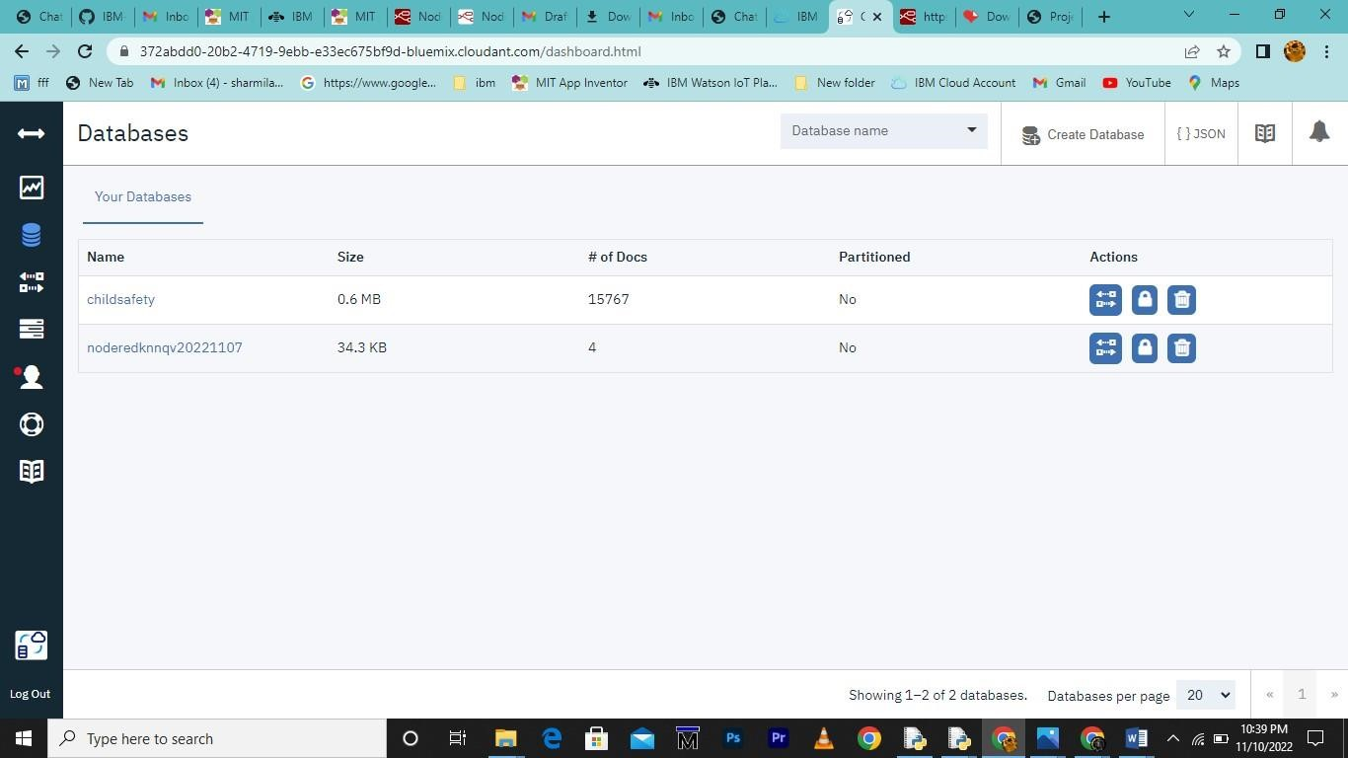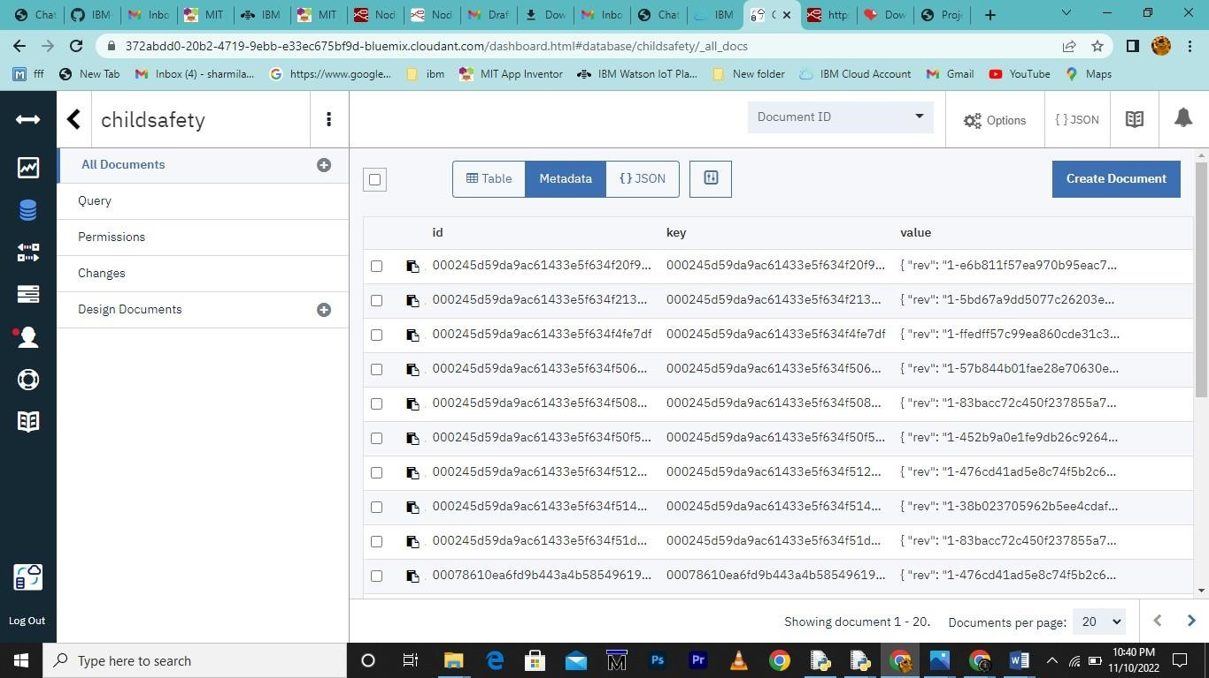

Node-Red Service with Clodant DB:

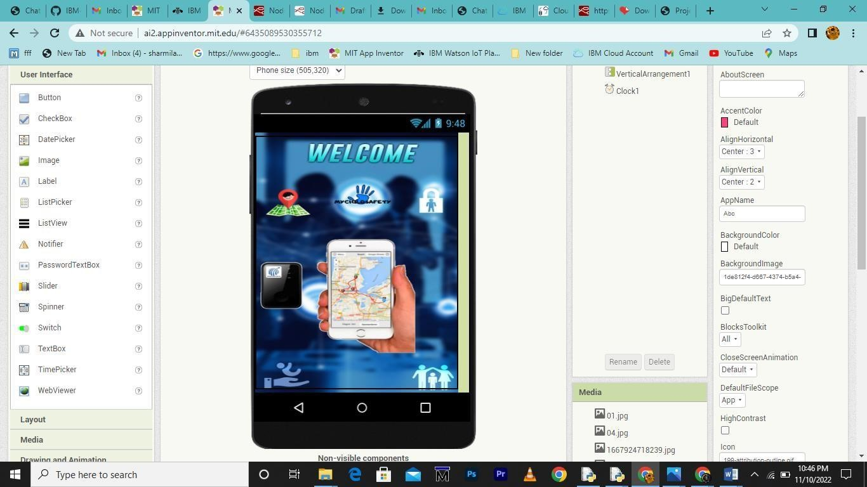

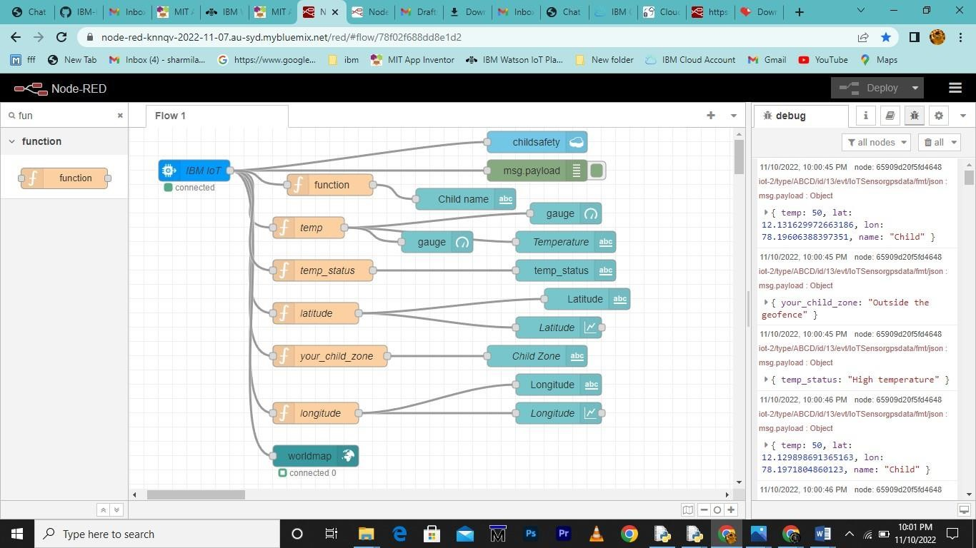

Create App in MIT app inventor:

